Lab 1 – Setting Up Flutter and Running Your First App
Exercise 1 – Flutter Environment Setup
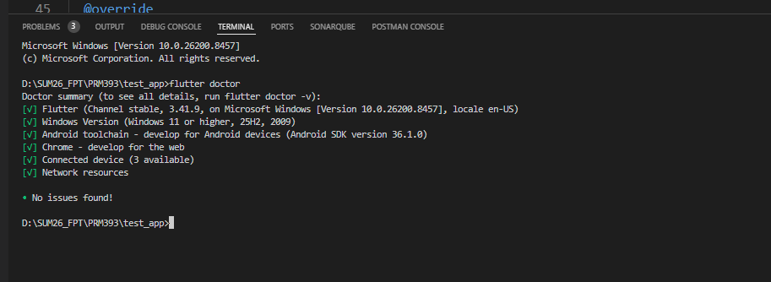

Exercise 2 – Create and Run Your First Flutter App
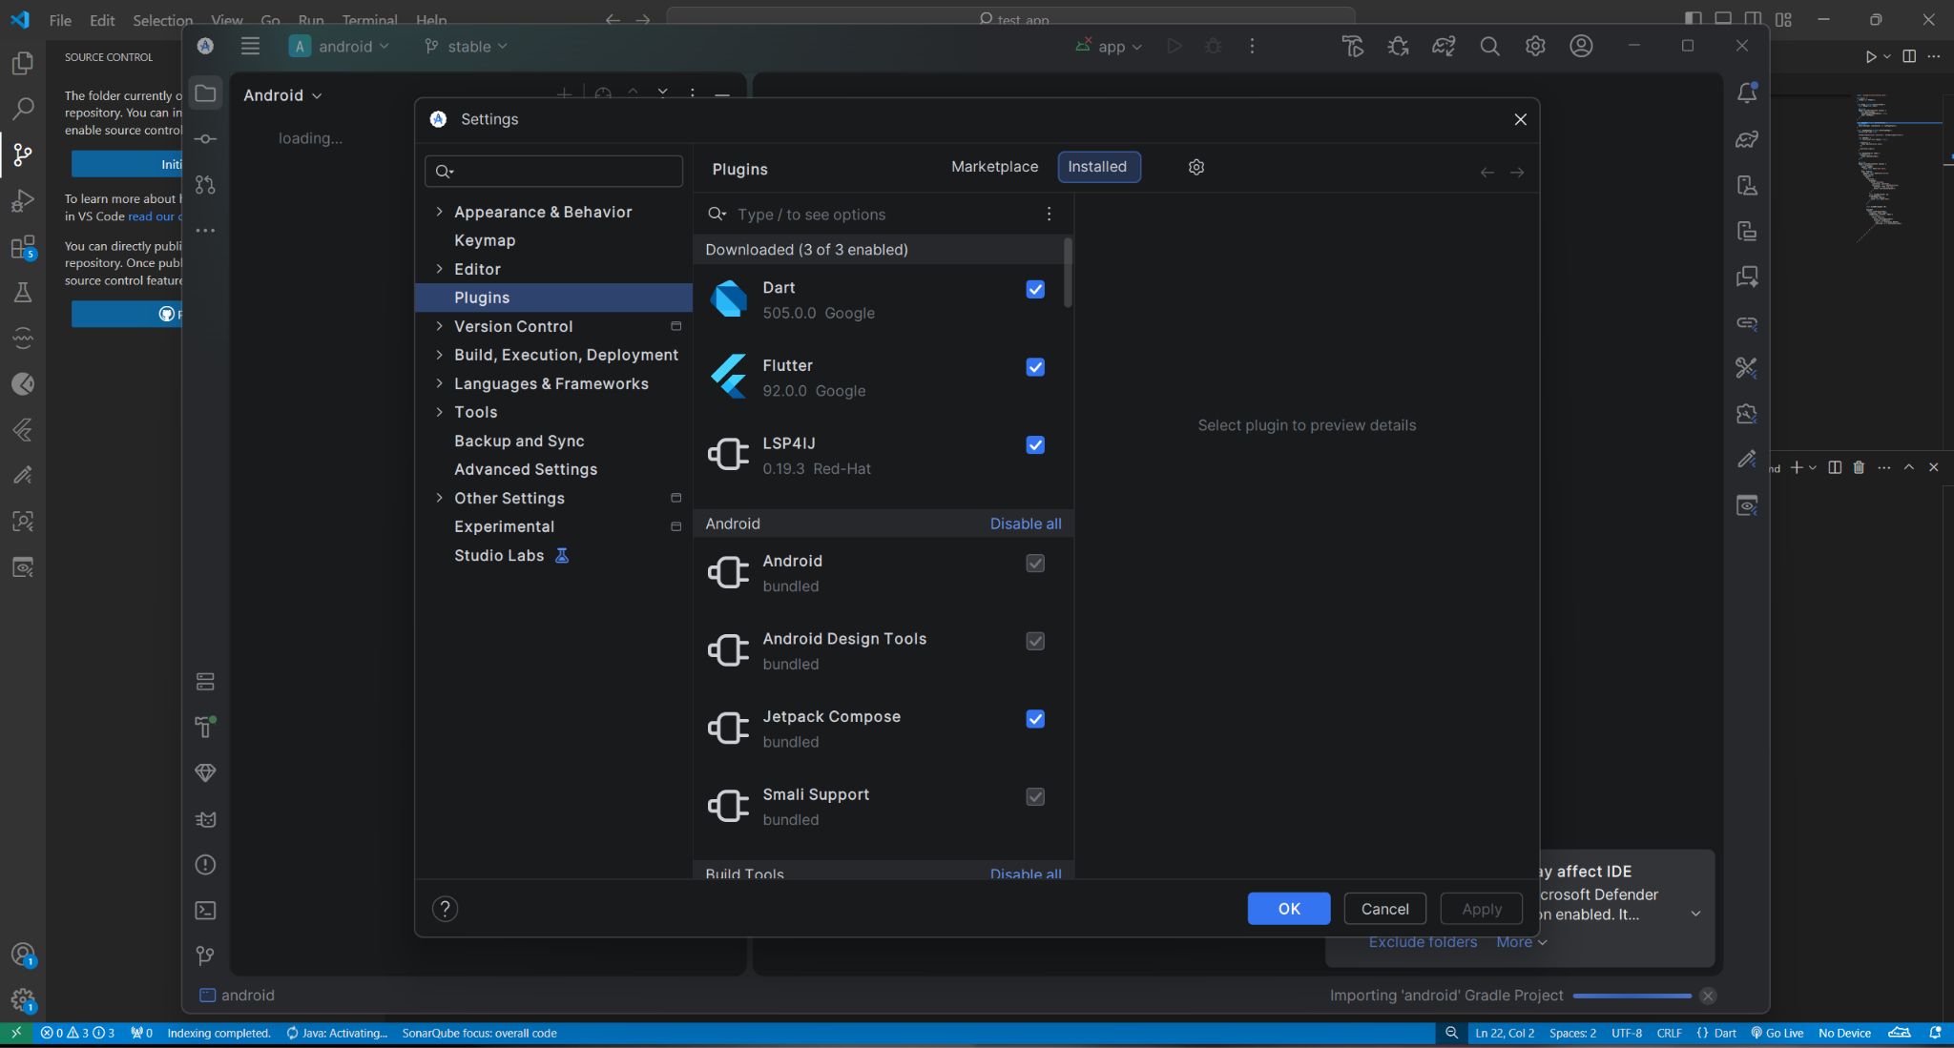

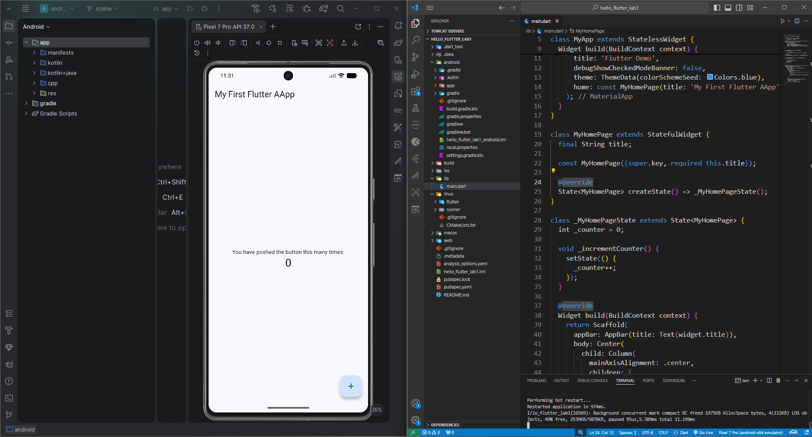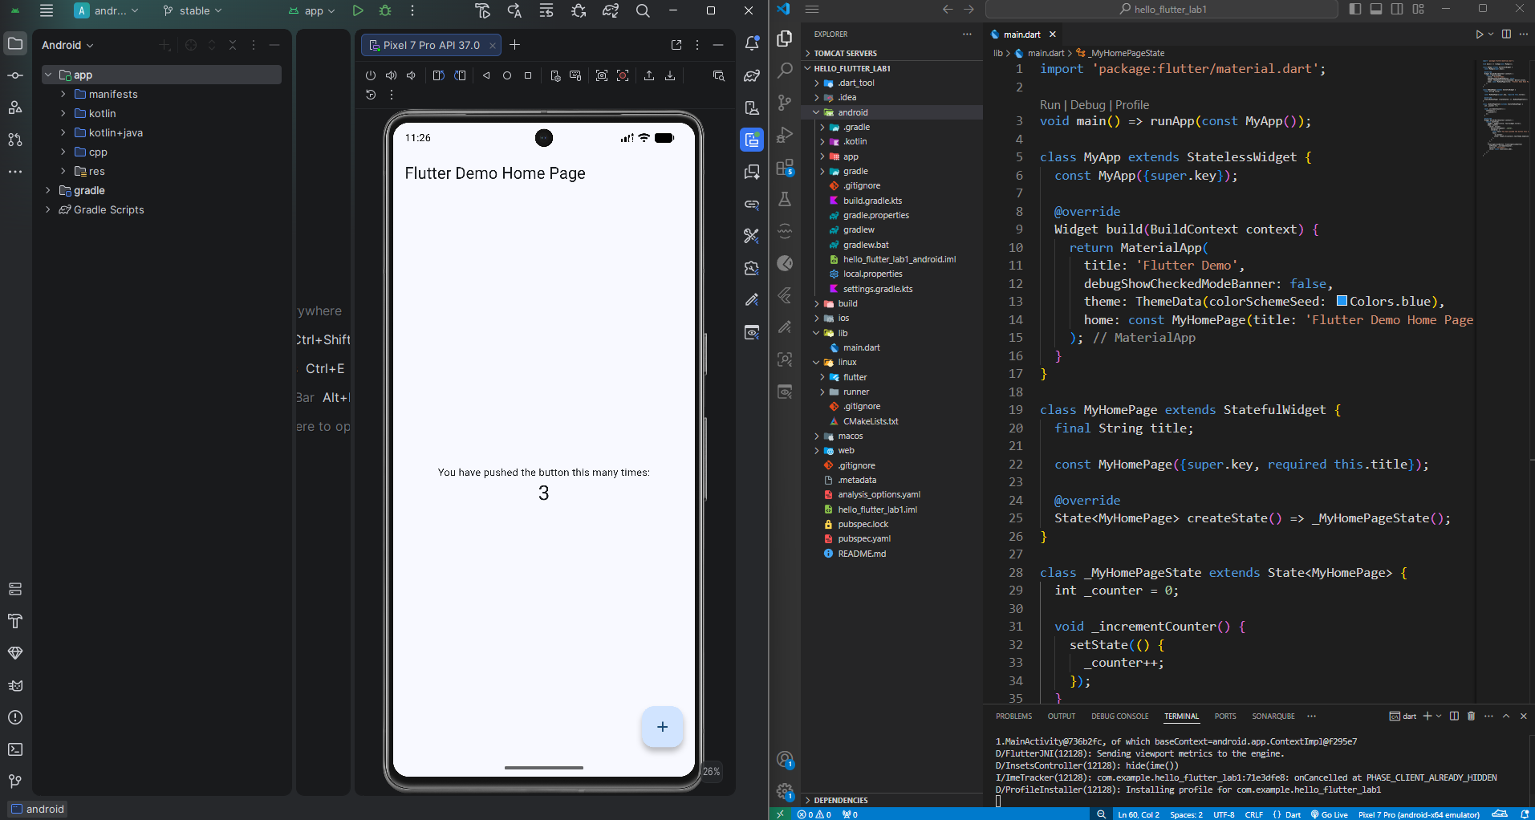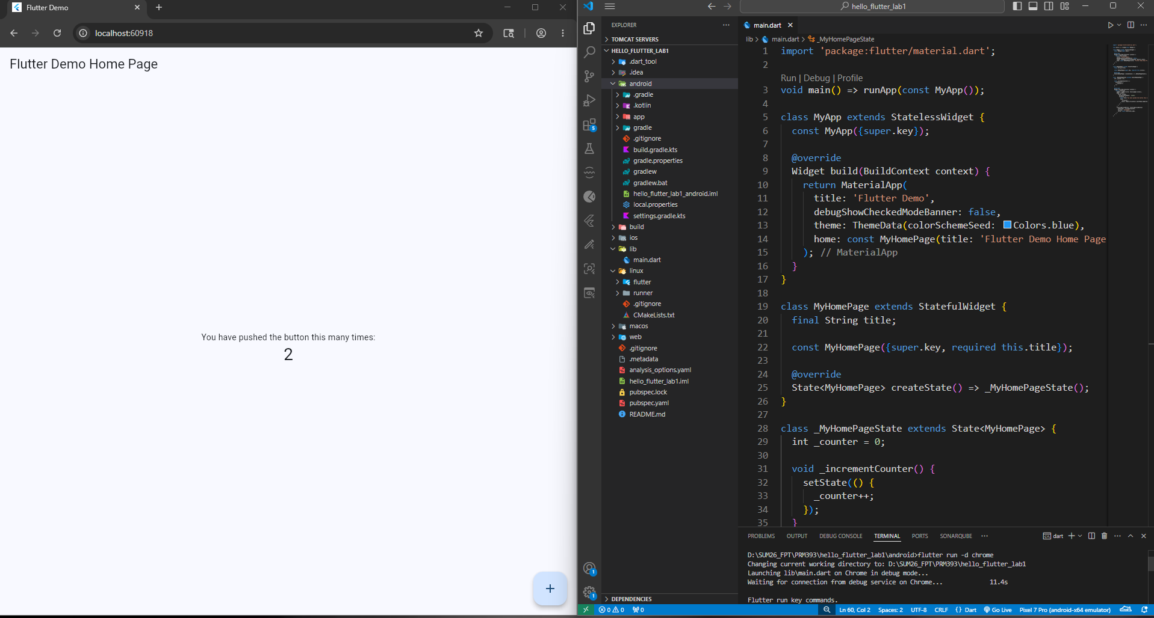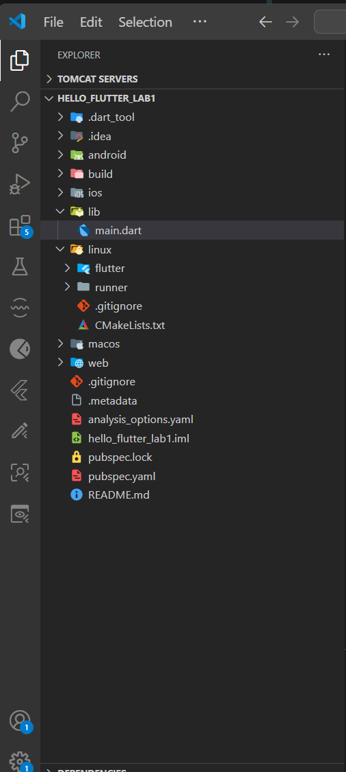

Exercise 3 – Customize Your First Flutter UI
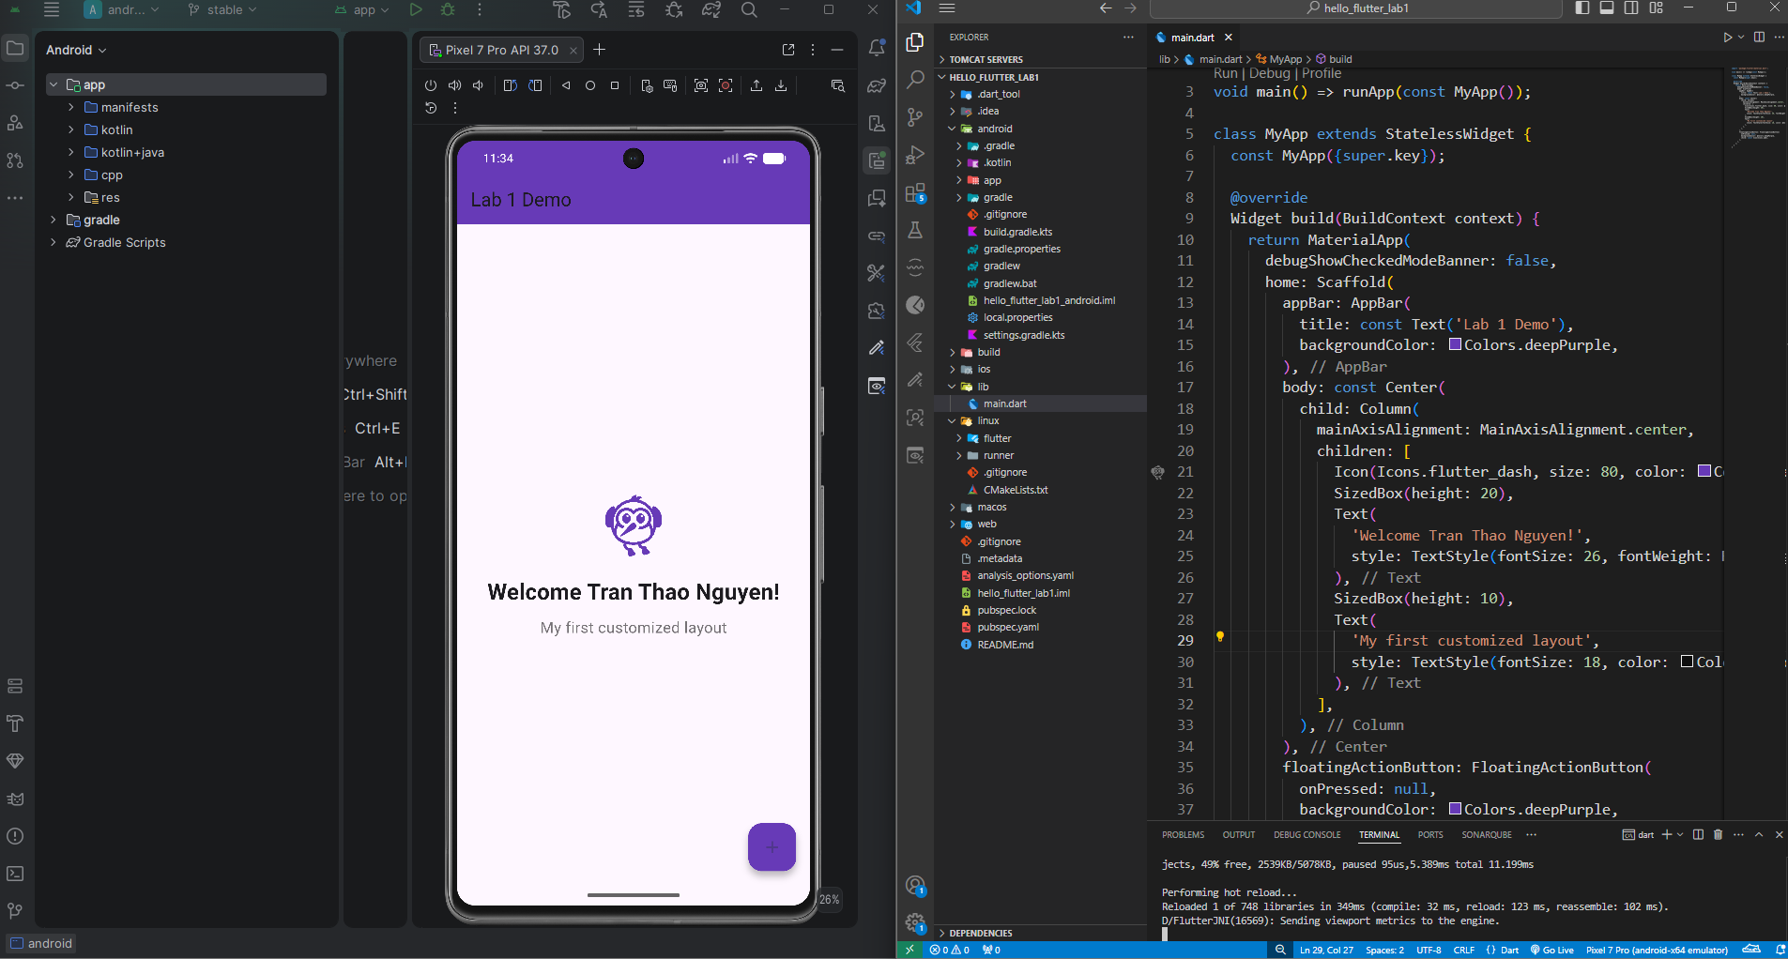

Exercise 4 – Reflection Questions
- What is the purpose of the flutter doctor command?
-> The flutter doctor command is used to diagnose the local environment. It checks for installed dependencies, core tools (like SDKs and IDEs), and provides a detailed report on what is missing or misconfigured.
- What file acts as the entry point of a Flutter application?
-> The entry point of a Flutter application is the main.dart file, which is located inside the lib/ directory.
- Explain the difference between Hot Reload and Hot Restart.
-> Hot Reload: Compiles the newly added code changes and injects them directly into the Dart Virtual Machine (VM). It updates the UI instantly without rebuilding the entire app widget tree, thus keeping the application state intact.
-> Hot Restart: Fully destroys the current application state, rebuilds the widget tree from scratch, and restarts the application from the initial entry point.
- How does runApp() build the widget tree?
-> The runApp() function takes a given root widget and attaches it to the screen. Flutter then evaluates and processes this root widget, expanding and building all its child widgets recursively to construct the complete user interface widget tree.
- Describe how Flutter’s architecture enables cross-platform development.
-> Flutter achieves cross-platform consistency by avoiding platform-specific native UI components. Instead, it uses its own high-performance graphics engine (like Impeller or Skia) to draw every pixel of the widget framework directly on the screen. This ensures the application looks and performs identically across Android, iOS, Web, and Desktop using a single, unified Dart codebase.

